Advanced Engineering Mathematics, by Erwin Kreyszig 10th. Ed.

**Problem Set 1.1**

No. 1



No. 2



No. 3



No. 4



No. 5



No. 6



No. 7



No. 8



No. 9



No. 10



No. 11



No. 12



No.13



No. 14



No.15



No. 16



No. 17

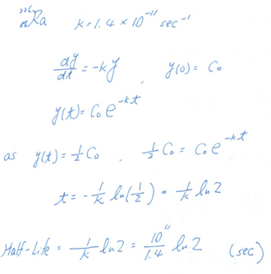

No. 18

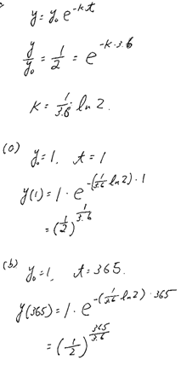

No. 19

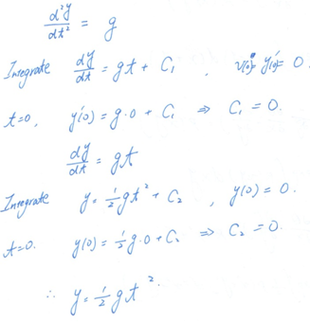

No. 20

